RDS-Task 01
Summary - Amazon RDS is an AWS service that provides managed relational databases. It automatically handles backups, maintenance, and scaling, making it easy to use databases in the cloud.
- Create MariaDB DB on EC2
Go to ec2 and launch instance in the name of Maria db
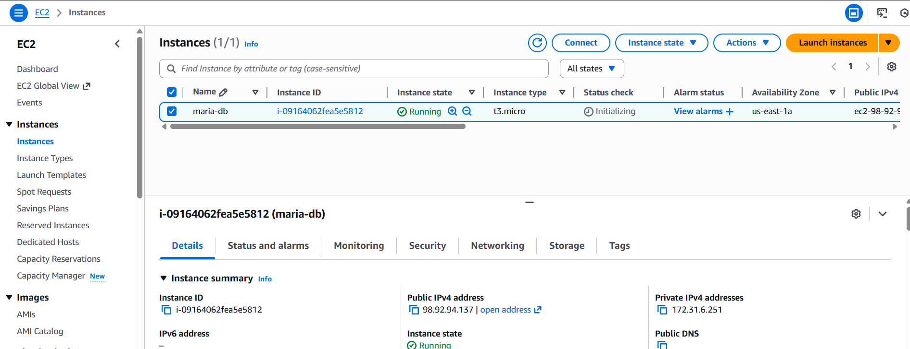
Now connect ec2 and install maria db
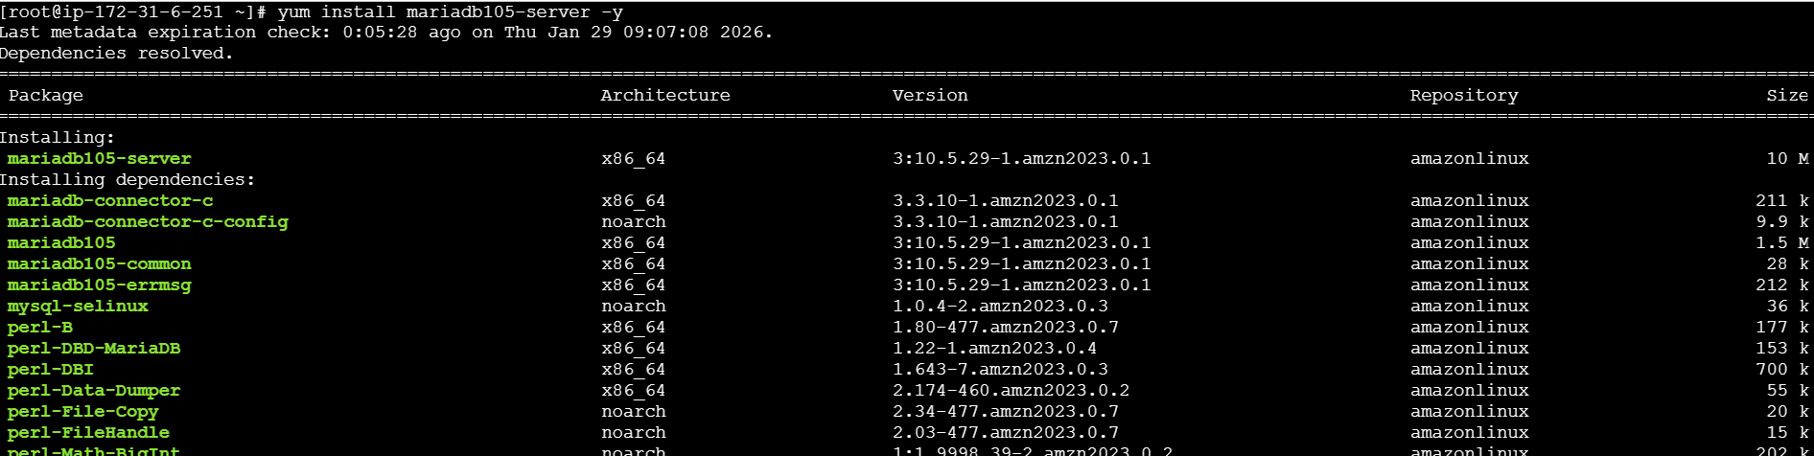
maria db installed and running
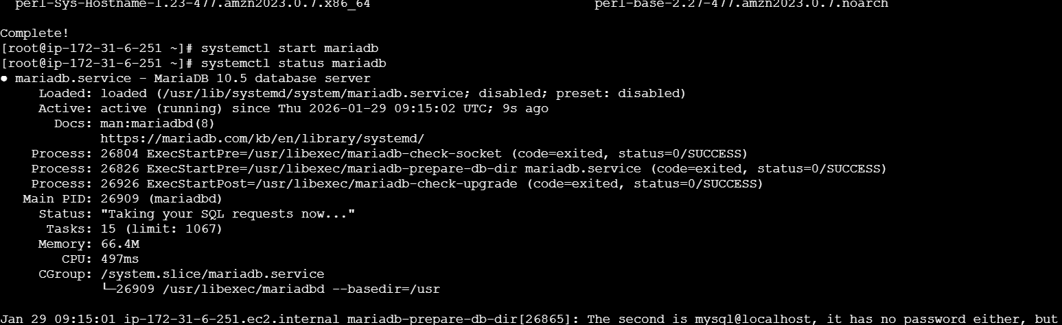
Now we have entered the commands to connect to the data base
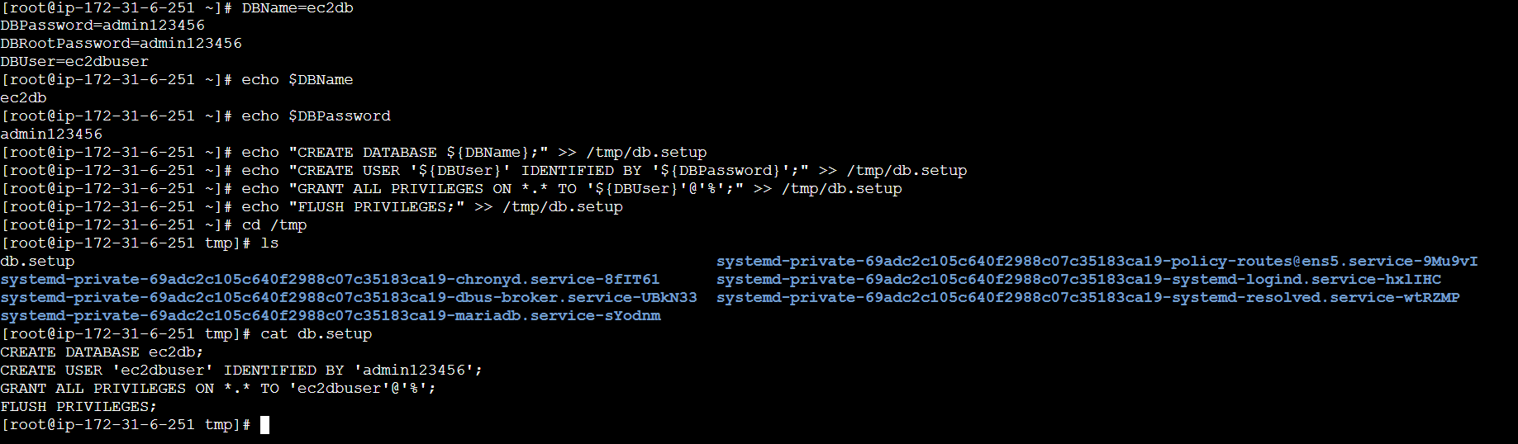
Now we have setup the DB in ec2 instance and we are inserting the file in to data base and removing the existing file we have created
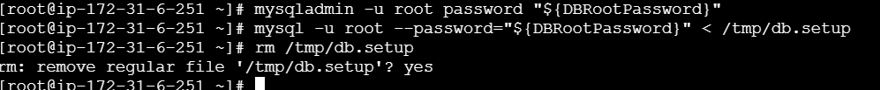
Now login to database
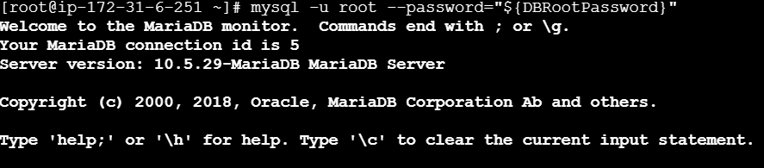
- Insert some dummy data
Login to database and see the databases
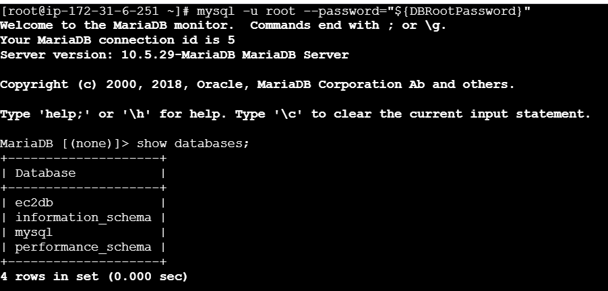
And use the database and insert the dummy data
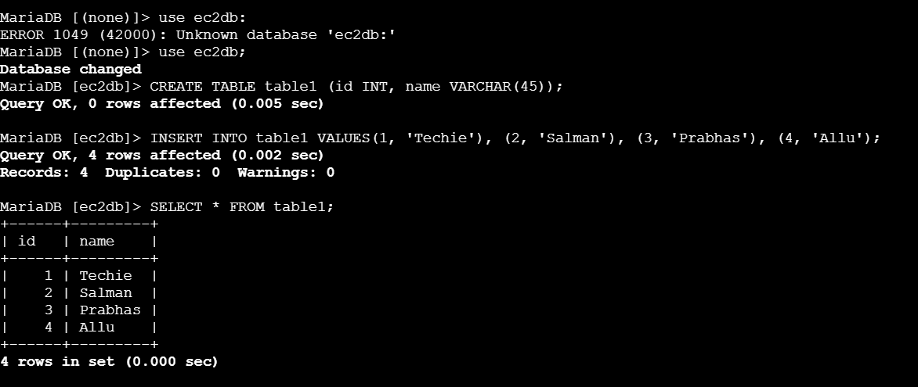
- Take the backup of dummy data on EC2
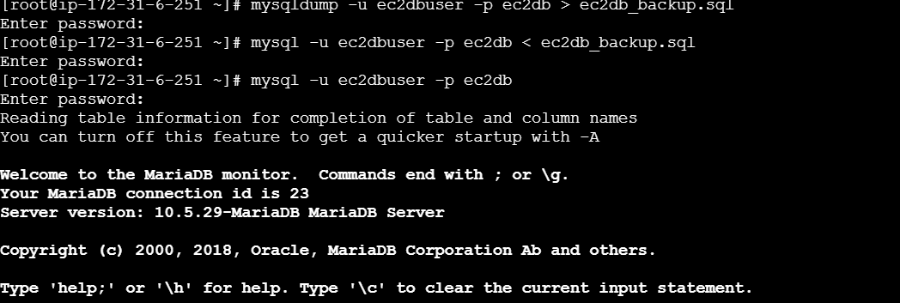
- Launch MariaDB RDS instance
In aws search for rds service and click on it and click on create database
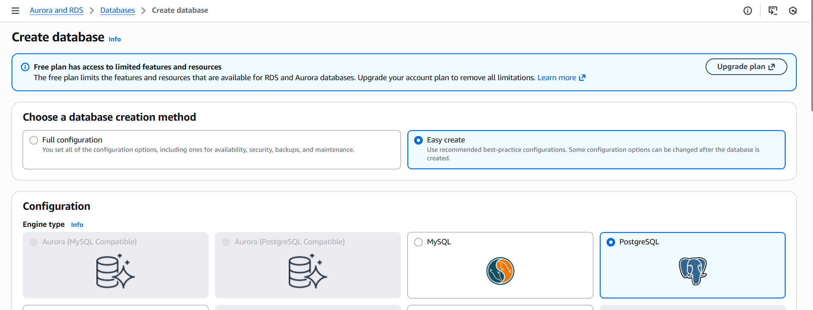
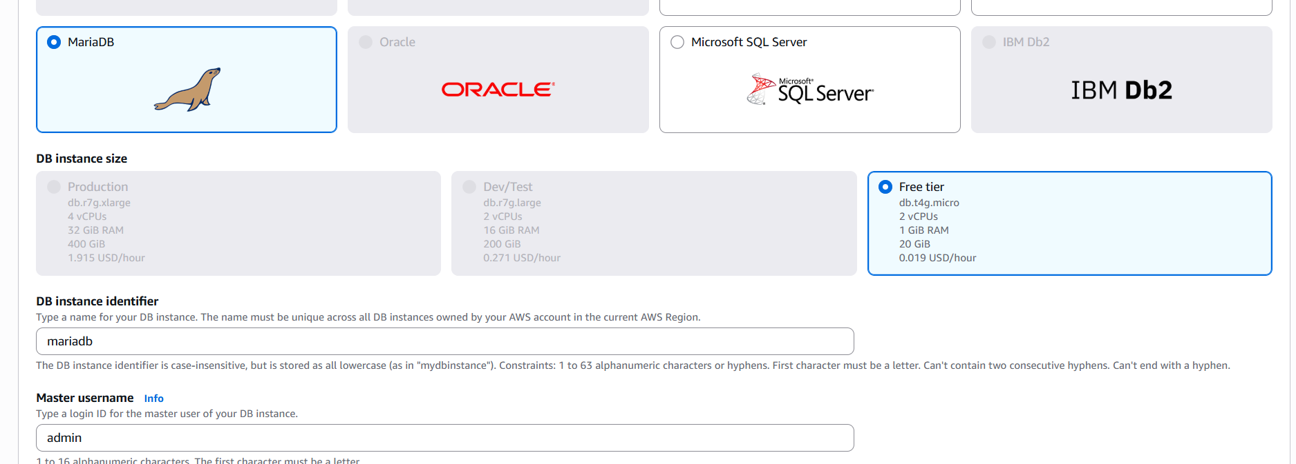
and provide password
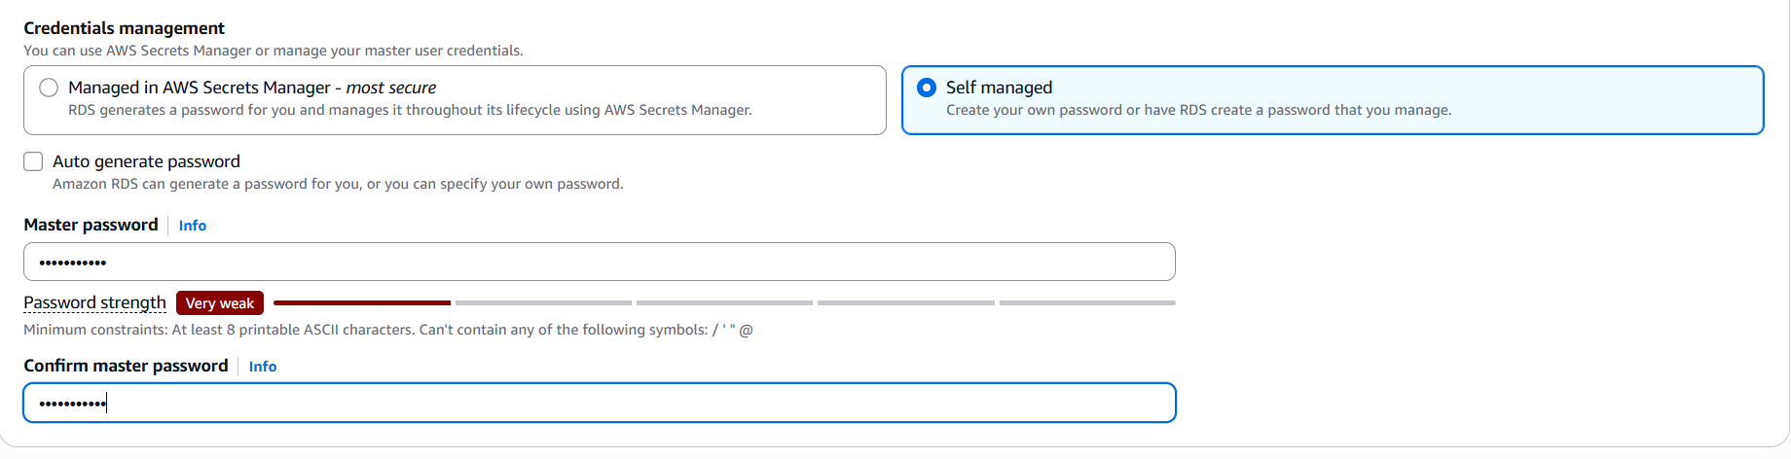
Then click on create database
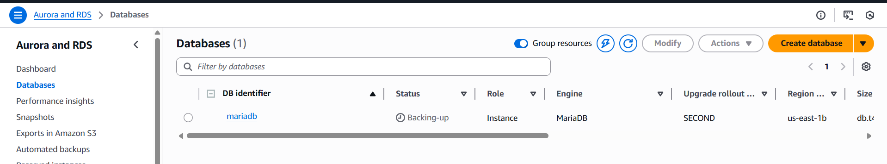
- Migrate database from EC2 to RDS
Login to database and add rdbs
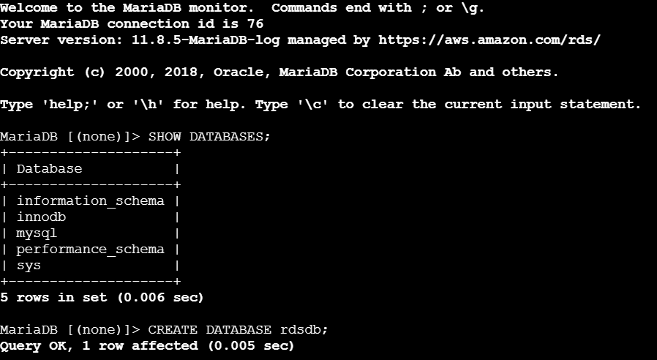
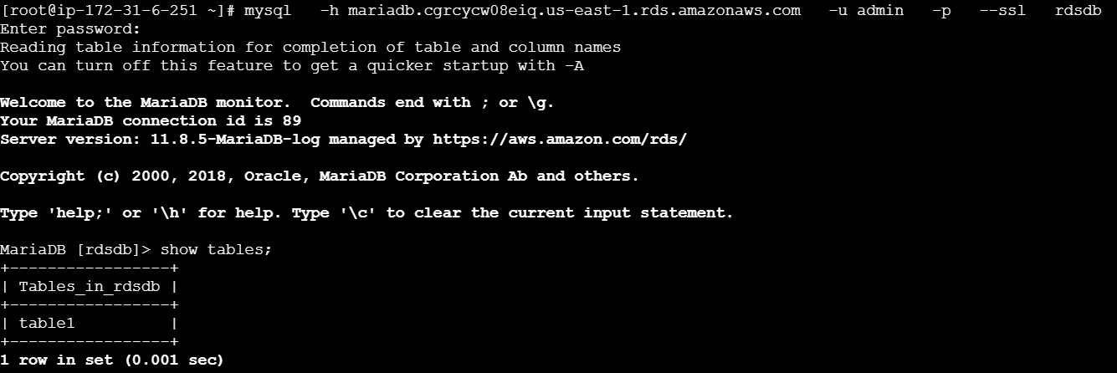
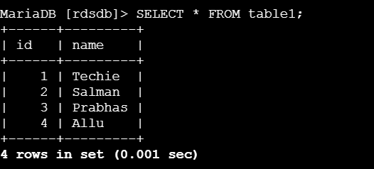
- Install MySQL DB on EC2
Launch an new instance in the name of mysqlDB
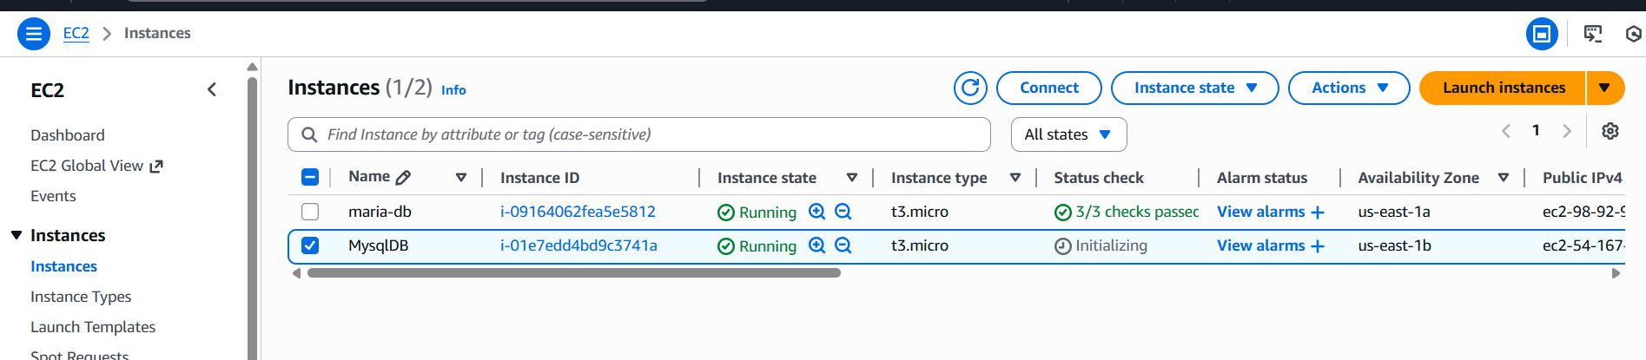
And connect it and install mysql
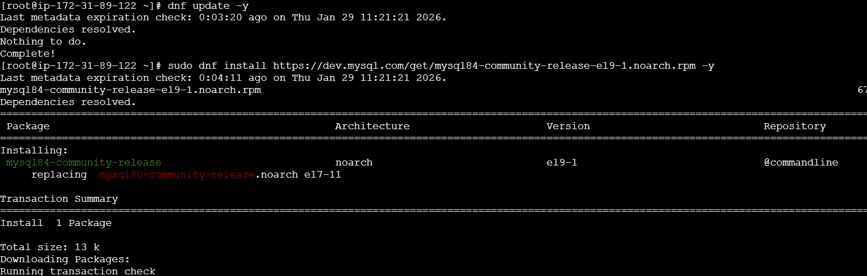
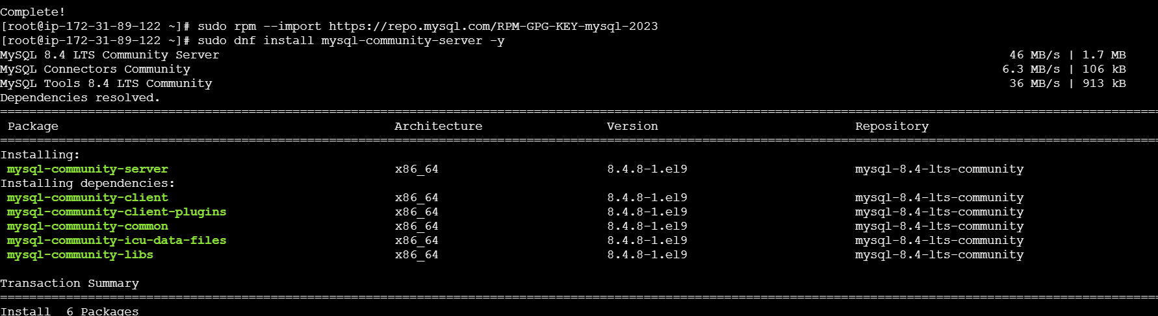
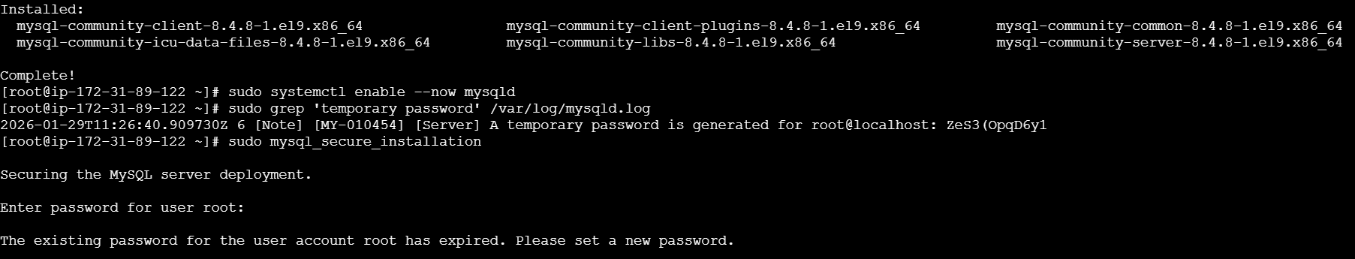
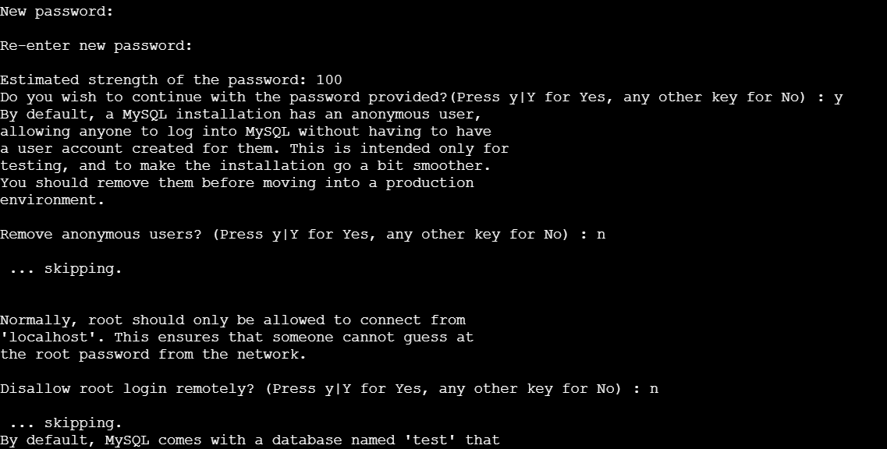
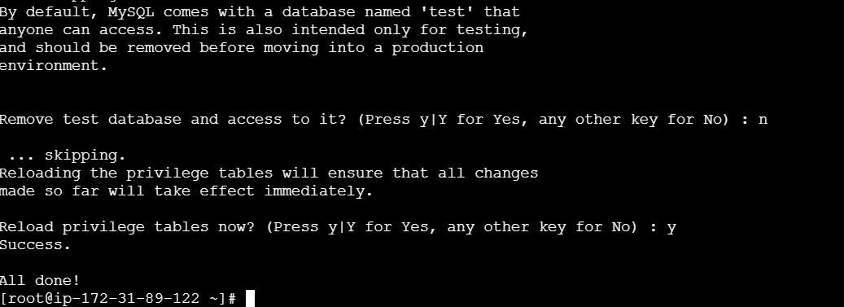
Mysql installed successfully and login to mysql
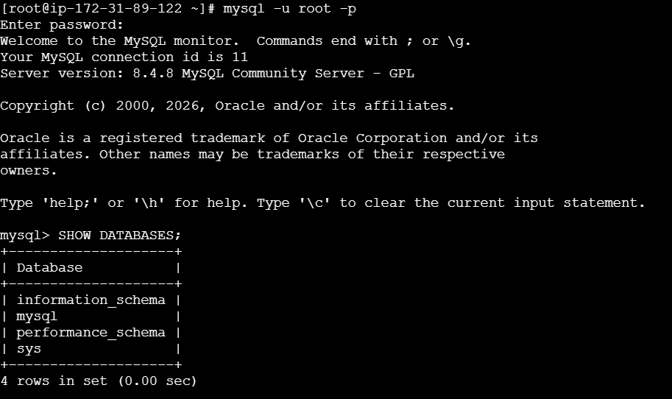
Now create a database
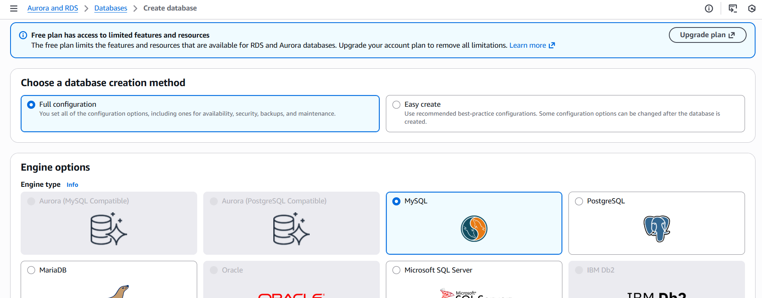
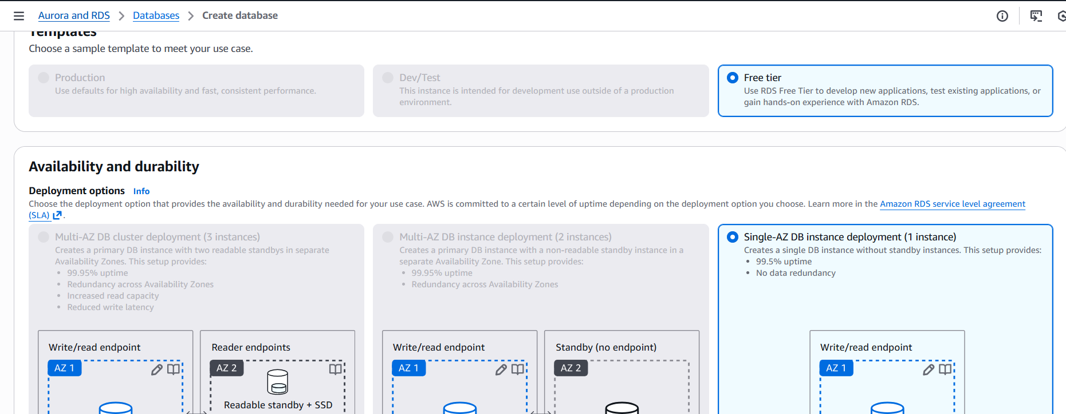
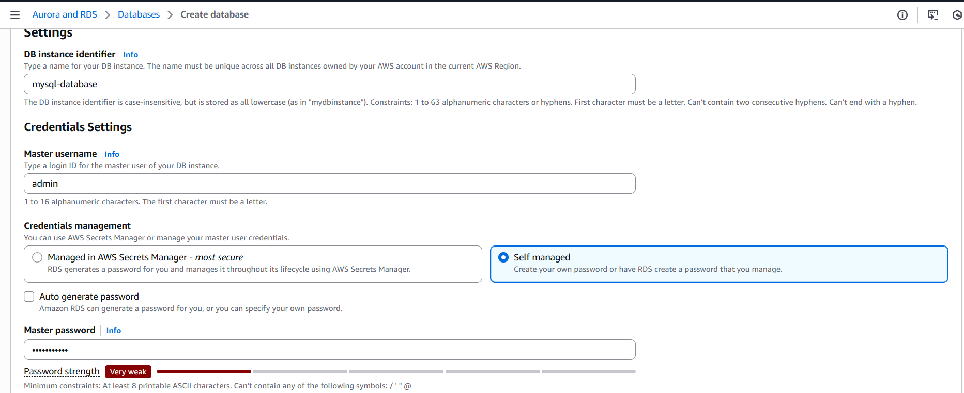
Then click on create database
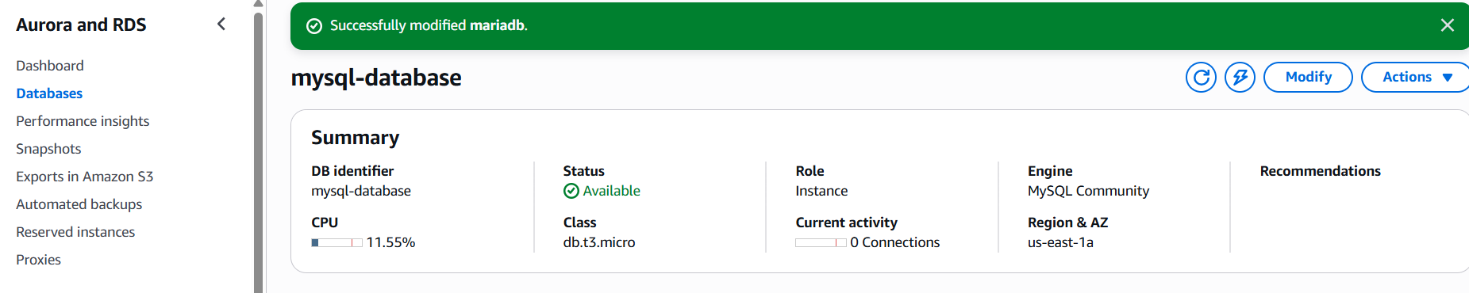
- Configure Multi-AZ
Search RDS in aws service and click on RDS and create a data base with full configuration
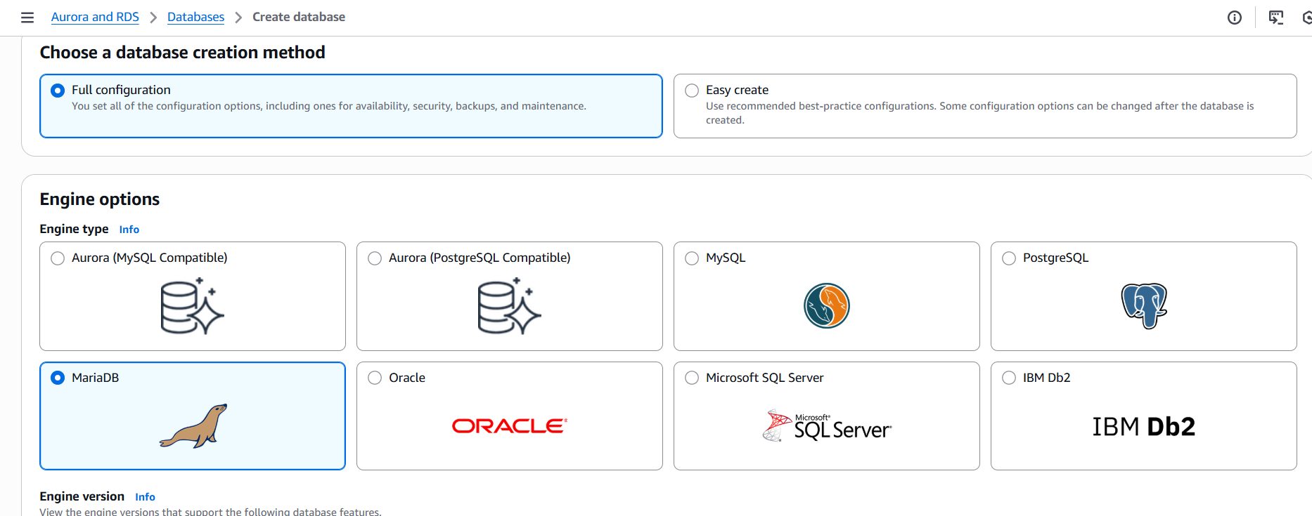
And select production and click on create a standby instance and then click on create database
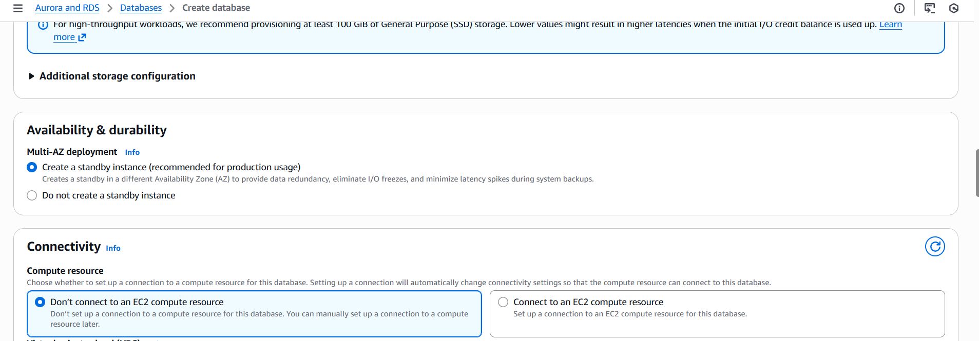
And click on configuration of database
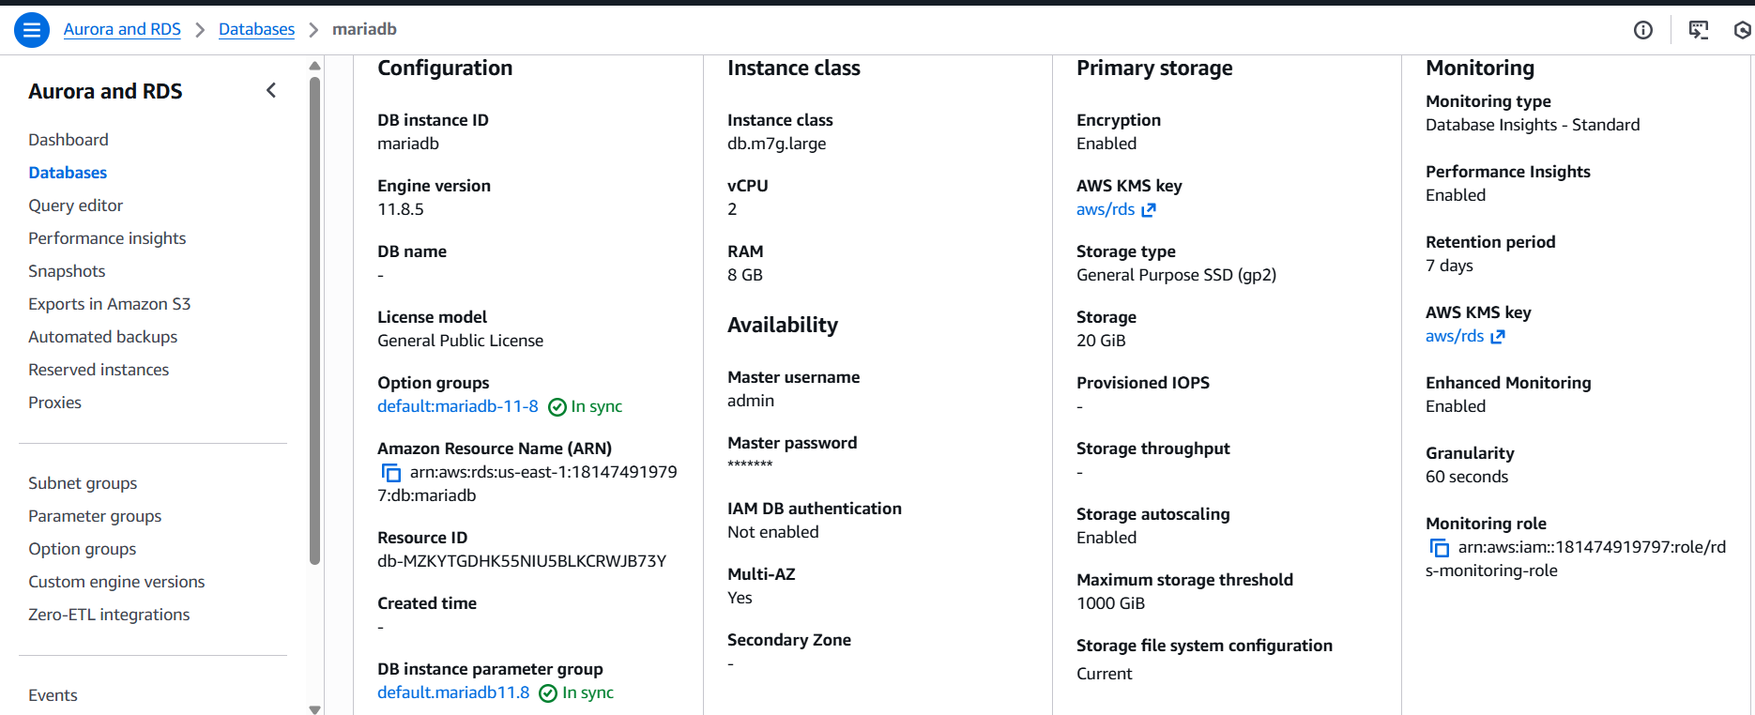
- Take backup of DB and restore the DB
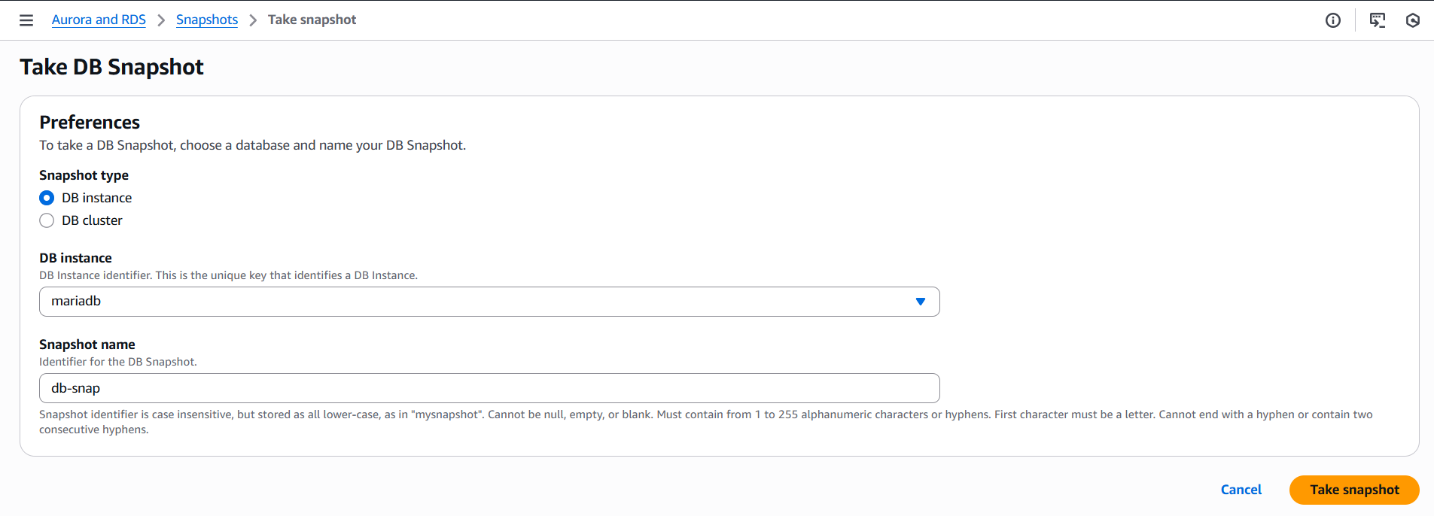
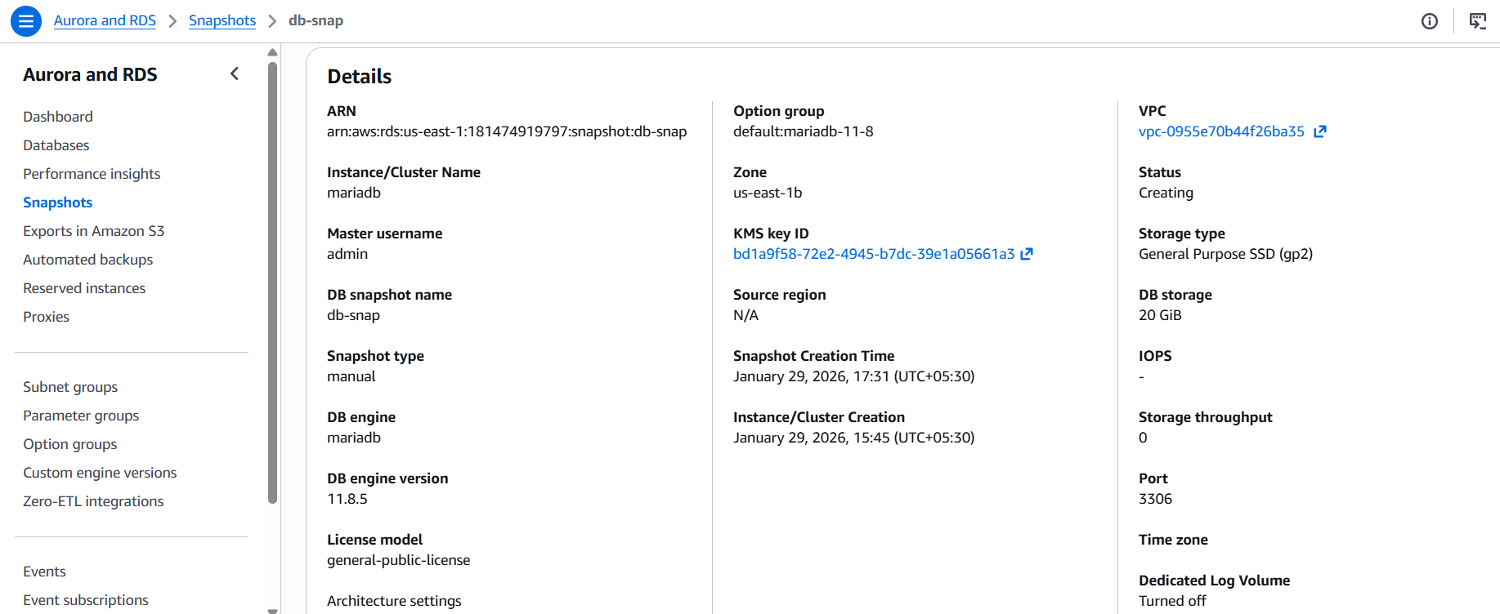
Snapshot created successfully now restoring the snapshot
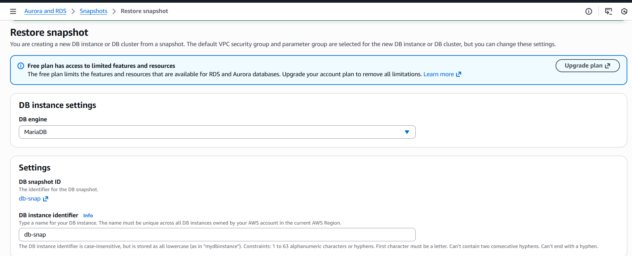
restored snap
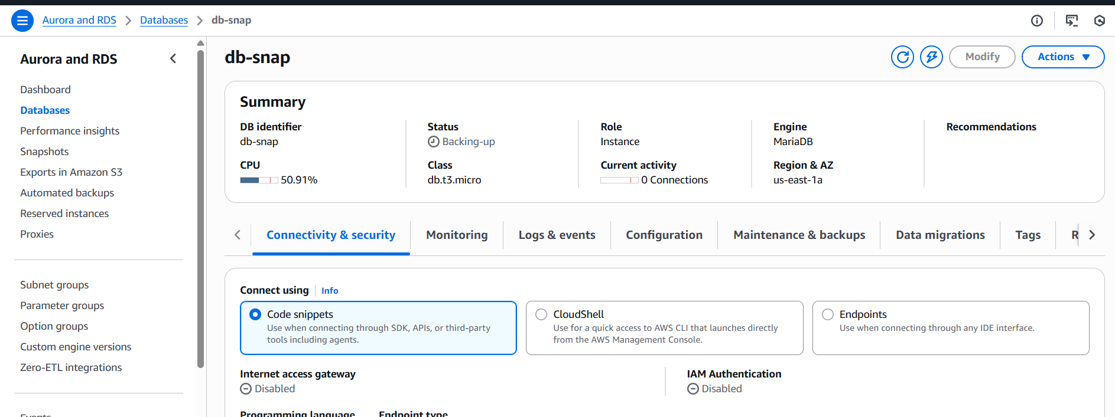
- Create a read replica
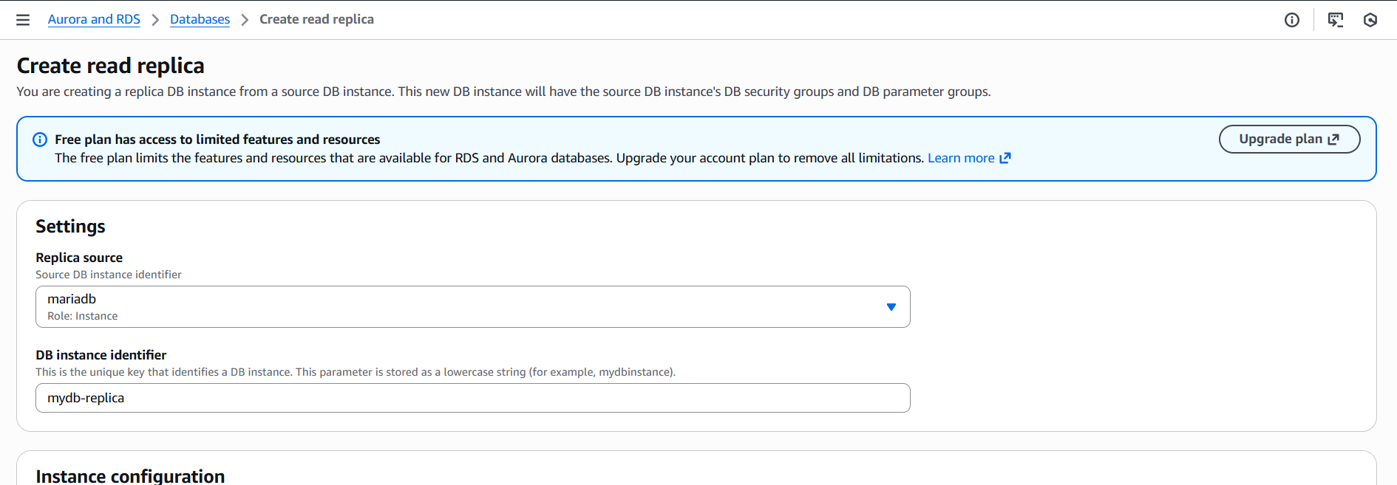
click on create replica
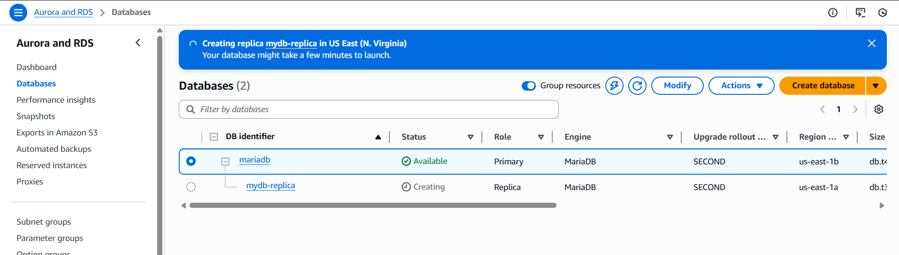
Replica created
